Exp: Restoring Algorithm
Aaron Gomes
UID: 2025300073

Aim: Implementation of division using Restoring Algorithm in C.

Code:
#include <stdio.h>

int N = 32; // Since 32 bit for int in dividend
unsigned A = 0;
unsigned M, Q;

void display();
int main()
{

printf("Enter Dividend (Q): ");
scanf("%u", &Q);
printf("Enter Divisor (M): ");
scanf("%u", &M);

while (N > 0)
{
// Shift Left AQ
// Shift just A (also take the 31st bit of Q and OR it with A's Last bit)
A = (A << 1) | ((Q >> 31) & 1U);

display();

// Shift just Q
Q = Q << 1;

display();
A = A - M;

if((A >> 31) & 1U)
{
Q &= ~1U; // Set Q's Last bit as 0
A = A + M;
}
else
{
Q |= 1U; // Sets Q's Last bit as 1
}
N--; // Decrement the counter
}
display();
return 0;
}

void display()
{
printf("Quotient (Q): %u\t", Q);
printf("Reminder (A): %u\n", A);
}

Output:
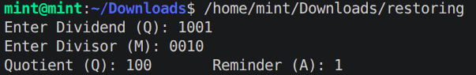

Conclusion:
Restoring Algorithm implemented to divide two 32 bit unsigned numbers and display the result.

